## **Navigating and Installing SCAP on Windows Server 2019**

### **Introduction to SCAP**

The Security Content Automation Protocol (SCAP) is a suite of specifications for standardizing the format and nomenclature by which software flaws and security configurations are communicated, both to machines and humans. SCAP is widely used in cybersecurity environments for compliance, vulnerability management, and security assessment.

### **Downloading SCAP**

This section will guide you through the steps of downloading the SCAP Tool from the [Public Cyber Exchange](https://public.cyber.mil/) .

1. Open your web browser and navigate to the [Cyber Exchange.](https://public.cyber.mil/)
2. Locate the SCAP section via the menu on the left ***Automation> Security Content Automation Protocol***

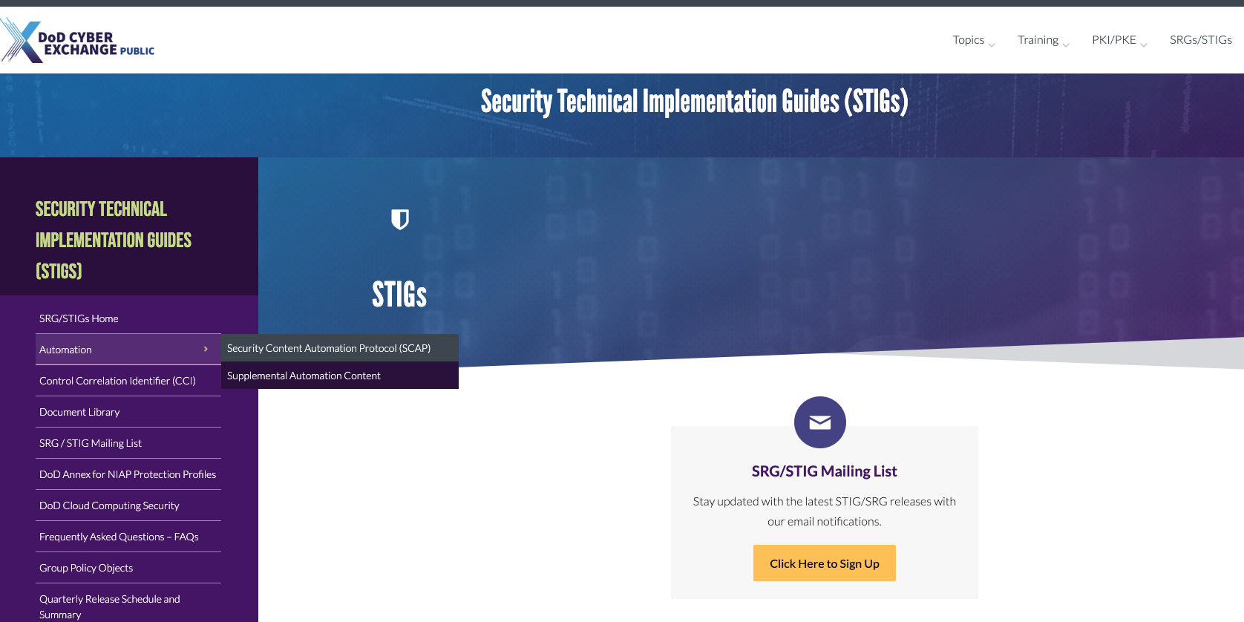

1. Select the appropriate SCAP version for Windows .

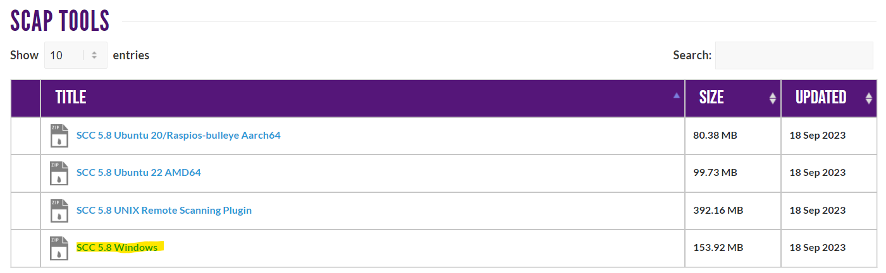

Once you have located SCAP on the website:

1. Click on the download link for SCAP.
2. Follow the prompts to save the file to your local system.

### **Installing SCAP on Windows Server**

Follow these steps to install SCAP on a Windows Server environment:

1. Locate the scc-5.8_Windows_bundle
2. Unzip the file to the same location
3. Click on the scc-5.8_Windows_bundle
4. Drill down in the files and locate the ‘scc’ application and install
5. Double-click the installer and follow the on-screen instructions to complete the installation.
6. On the ‘Windows protected your PC’ screen, click ‘More info’ and navigate to the ‘Run anyway’
7. Once installed, launch SCAP and follow any setup wizards or instructions to configure it for first-time use.

Note: The steps may vary slightly depending on the version of SCAP and the configuration of your Windows Server. It is recommended to consult any accompanying documentation for specific installation details.

### **Conclusion**

This guide has provided you with the necessary steps to navigate, download, and install SCAP on Windows Server 2019. By following these instructions, you should be able to successfully set up SCAP for your cybersecurity needs.